
Name:Ayush Bhalerao Std: XII Div: Science CBSE
Board Seat No.
Subject: Informatics Practices Practical File
School Roll No.:05
Year: 2025-26

City Pride School Pradhikaran, Nigdi-411044

INDEX
Python Programs

Sr.  No. | Name of the program | Page No. | Date | Remark | Sign of teacher
1 | Create panda series from a dictionary of values and ndarray. | 5 | 16-04-2025
2 | In a given series, print all the elements that are above 75th percentile. | 6 | 16-04-2025
3 | Write a program to generate a series of float numbers from 21.0 to 30.0 with an increment of 1.5 each. | 6 | 21-04-2025
4 | Write a program to generate series using dictionary to represent month number and month names. | 7 | 21-04-2025
5 | Write a program to generate a series of 5 elements of multiples of 7 starting with 35 with index multiplied by 3. | 7 | 22-04-2025
6 | Write a program to generate series of marks of 10 students. If marks are < 33, give grace of 5 marks and print new list of marks. | 8 | 22-04-2025
7 | Write a program to create a DataFrame of quarterly sales where each row contains item category, item name and expenditure. Group the rows by category and print total expenditure per category. | 9 | 05-06-2025
8 | Write a program to create a DataFrame for student data– Name, Percentage, PhoneNumber, Hobbies. Display row labels, column labels and data type of each column and dimensions. | 10 | 05-06-2025
9 | Write a program to accept data from user dynamically and change it in a DataFrame. | 10 | 12-06-2025
10 | Write a program to create a DataFrame and print the top and bottom 3 values of DataFrame. | 11 | 12-06-2025
11 | Write a program to create 2 DataFrames. Display their sum and difference. | 12 | 24-06-2025
12 | Write a program to create a DataFrame below.  Rename zone C and zone D as ‘Central’ and ‘South’. | 13 | 24-06-2025
13 | Write a program to create a DataFrame of Doctor with columns (Name, Department, Experience). Add a new column Bonus with values as twice as the experience and delete the third row with index 3. | 13 | 01-07-2025
Sr.  No. | Name of the program | Page No. | Date | Remark | Sign of teacher
14 | Write a program to create a DataFrame. Print original DataFrame. Filter and print duplicate data in data frame. | 14 | 01-07-2025
15 | Create a DataFrame and extract data row-wise. | 15 | 15-07-2025
16 | Write a program to create an employee database that consists of employee ID, Name, Department of 10 employees as a CSV file and create a DataFrame from it. | 16 | 15-07-2025
17 | Write a program to create a DataFrame of marks of 3 subjects of 5 students and write it in CSV file. | 17 | 22-07-2025
18 | Write a program to plot a line chart  of a student marks that analyses his data. | 17 | 22-07-2025
19 | Write a program to plot a barchart in python to display result of school for five consecutive years. | 18 | 08-08-2025
20 | Create a bar graph for the DataFrame given below. | 19 | 08-08-2025
21 | Write a program to plot a horizontal bar chart from the heights of 5 students using proper title, label, legends. | 20 | 16-08-2025
22 | Write a program to take data from an open source (data.gov.in). | 21 | 16-08-2025

INDEX
SQL Queries
Sr.  No. | Name of the program | Page No. | Date | Remark | Sign of teacher
1 | Write a query to create a student table with student id, name, marks, phno, address. Insert records in it. | 22 | 01-09-2025
2 | Write a query to insert a new row in student table. | 23 | 01-09-2025
3 | Write a query to display details of students with marks > 80. | 24 | 04-09-2025
4 | Write a query to delete details of a student from above table. | 24 | 04-09-2025
5 | Write a query to display all names in lower case | 25 | 23-09-2025
6 | Write a query to display complete table after rounding off data to 1 decimal place | 25 | 23-09-2025
7 | Write a query to display occurrence of string ‘a’ in names | 26 | 30-09-2025
8 | Write a query to display weekday of date of birth of all students | 26 | 07-10-2025
9 | Write a query to display count of names of students starting from ‘M’ | 27 | 07-10-2025
10 | Write a query to find min, max, sum and average of marks in student table | 27 | 17-10-2025
11 | Write SQL Query to print student_id and marks in the descending order of marks. | 28 | 17-10-2025
12 | Write a query to find total number of students residing in a particular area using group by. | 28 | 04-11-2025
13 | Write a query to :  A. Create a table marks that stores marks of students for 3 subjects physics, chemistry, maths, student names.  B. Join the two tables (student and marks) and print the complete data. | 29 | 04-11-2025
14 | Write a query to print name, address and physics, chemistry, maths marks. | 29 | 14-11-2025
15 | Write query to print name and total of physics, chemistry & maths marks | 30 | 14-11-2025

PYTHON PROGRAMS

- Create panda series from a dictionary of values and ndarray. CODE:
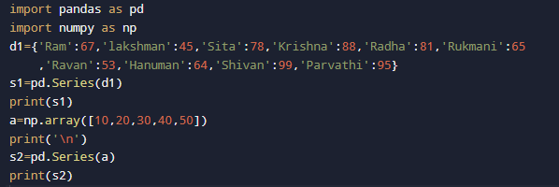
OUTPUT:
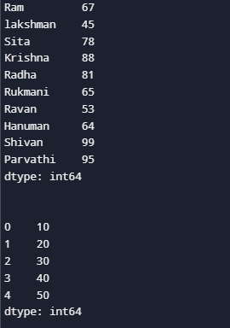

- In a given series, print all the elements that are above 75th percentile.
CODE:
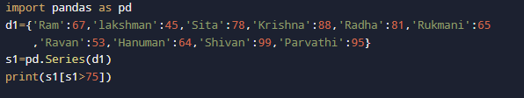
OUTPUT:
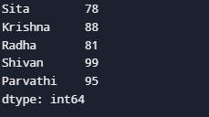
- Write a program to generate a series of float numbers from 21.0 to
30.0 with an increment of 1.5 each. CODE:
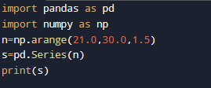

OUTPUT:
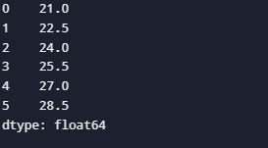

- Write a program to generate series using dictionary to represent month number and month names.
CODE:
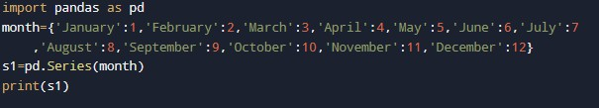

OUTPUT:
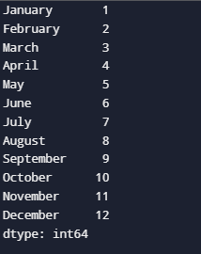
- Write a program to generate a series of 5 elements of multiples of 7 starting with 35 with index multiplied by 3.
CODE:
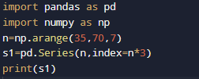

OUTPUT:
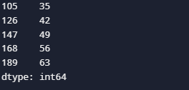

- Write a program to generate series of marks of 10 students. If marks are < 33, give grace of 5 marks and print new list of marks. CODE:
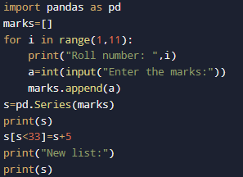

OUTPUT:
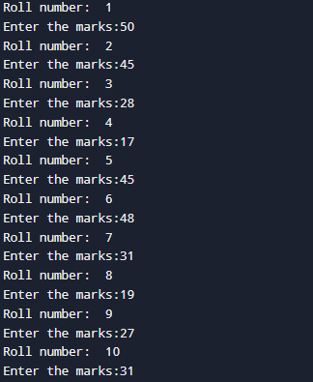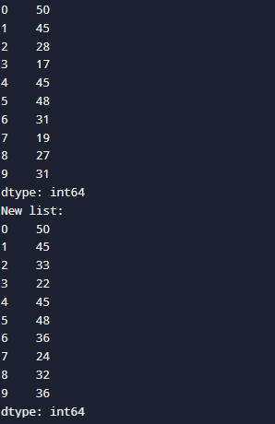

- Write a program to create a DataFrame of quarterly sales where each row contains item category, item name and expenditure. Group the rows by category and print total expenditure per category.
CODE:
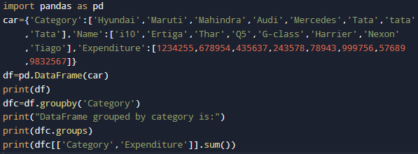
OUTPUT:
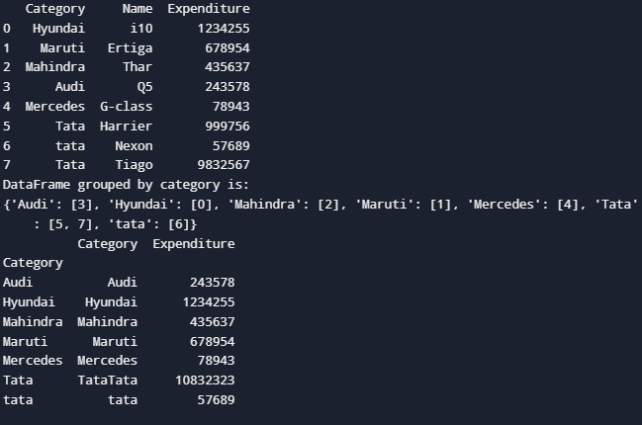

- Write a program to create a DataFrame for student data– Name, Percentage, PhoneNumber, Hobbies. Display row labels, column labels and data type of each column and dimensions.
CODE:
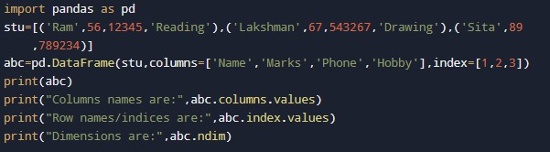

OUTPUT:
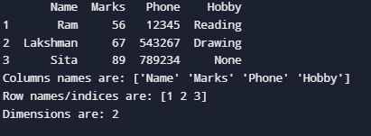

- Write a program to accept data from user dynamically and change it in a DataFrame.
CODE:
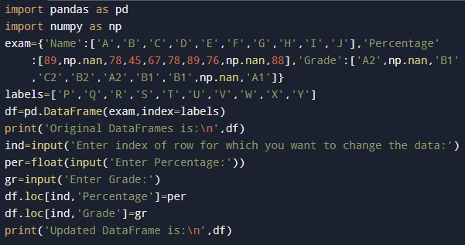

OUTPUT:

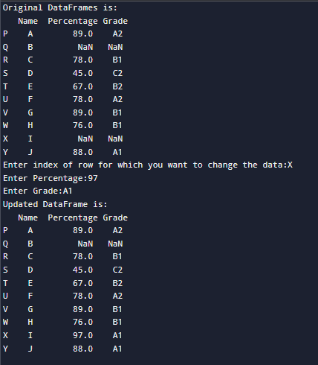
- Write a program to create a DataFrame and print the top and bottom 3 values of DataFrame.
CODE:
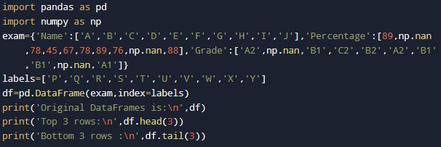

OUTPUT:

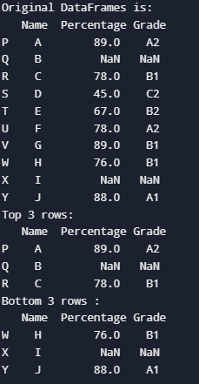
- Write a program to create 2 DataFrames. Display their sum and difference.
CODE:
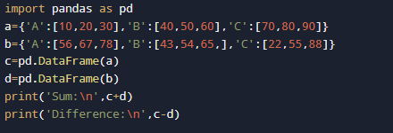

OUTPUT:
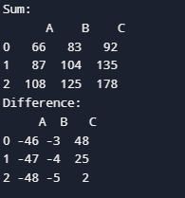

- Write a program to create the DataFrame below. Rename Zone C and Zone D as ‘Central’ and ‘South’.
CODE:
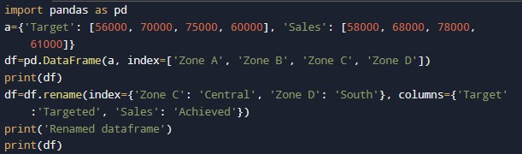
OUTPUT:
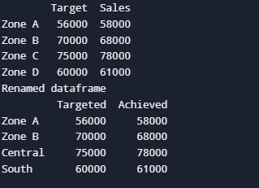

- Write a program to create a DataFrame of Doctor with columns (Name, Department, Experience). Add a new column Bonus with values as twice as the experience and delete the third row with index 3.
CODE:
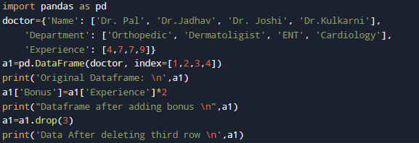
OUTPUT:

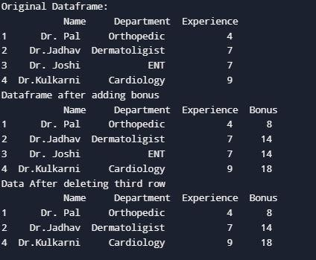

- Write a program to create a DataFrame. Print original DataFrame. Filter and print duplicate data in data frame. CODE:
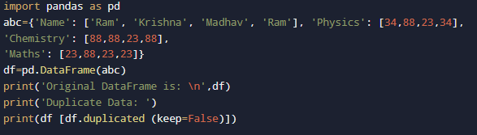

OUTPUT:
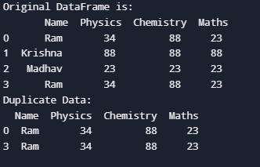

- Create a DataFrame and extract data row-wise. CODE:

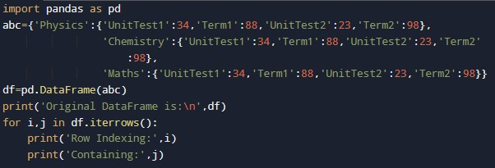
OUTPUT:
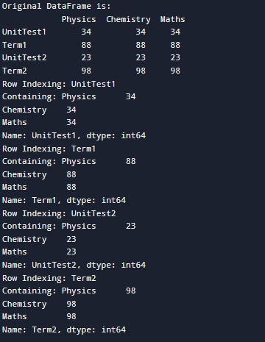

- Write a program to create an employee database that consists of employee ID, Name, Department of 10 employees as a CSV file and create a DataFrame from it.
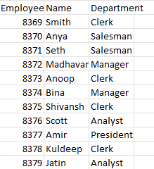
CSV FILE:

CODE:
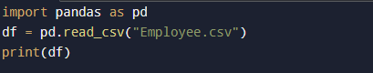
OUTPUT:
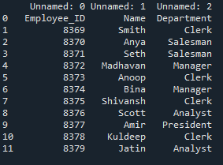

- Write a program to create a DataFrame of marks of 3 subjects of 5 students and write it in CSV file.
CODE:
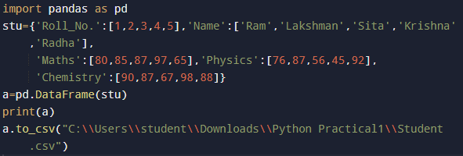

OUTPUT:
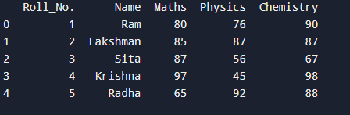
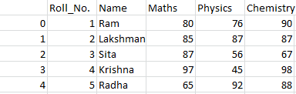

- Write a program to plot a line chart of a student’s marks that analyses his data.
CODE:
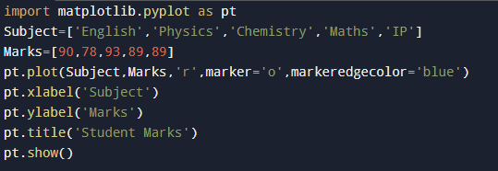

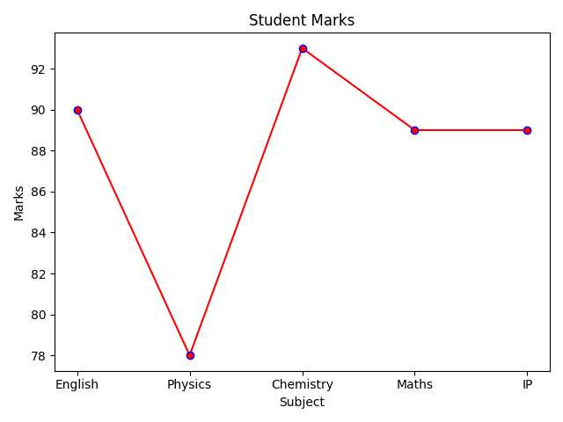
OUTPUT:

- Write a program to plot a barchart in python to display result of school for five consecutive years.
CODE:
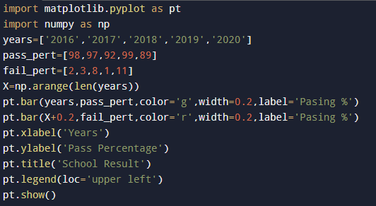

OUTPUT:
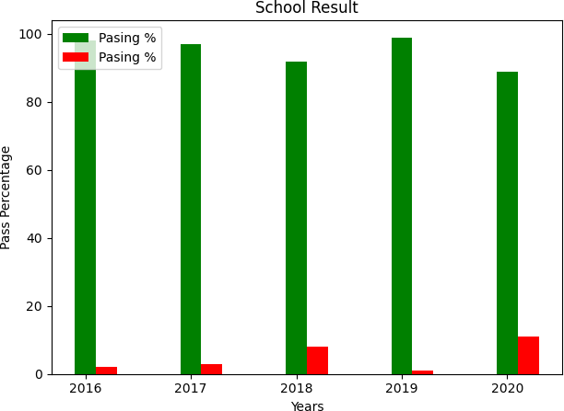

- Create a bar graph for the DataFrame given below. CODE:
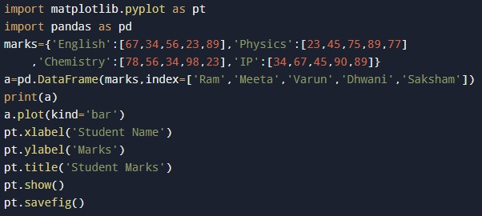

OUTPUT:
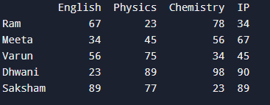

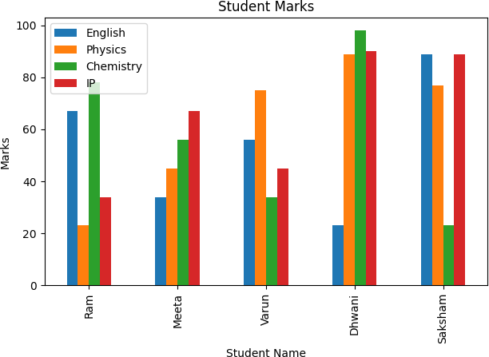

- Write a program to plot a horizontal bar chart from the heights of 5 students using proper title, label, legends.
CODE:
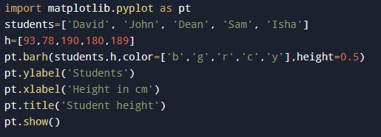
OUTPUT:
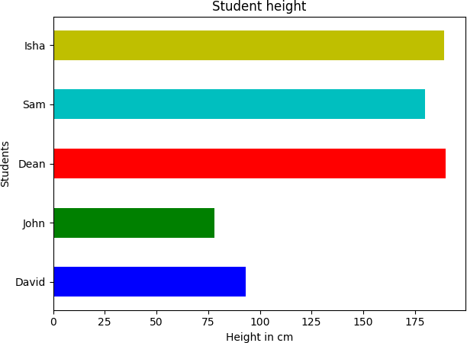

- Write a program to take data from an open source (data.gov.in). CSV FILE:
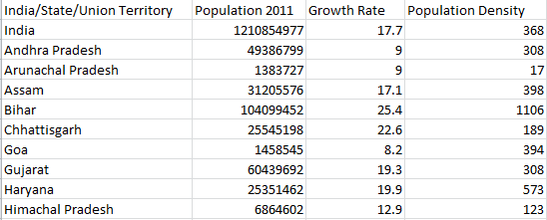

CODE:
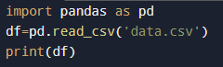

OUTPUT:
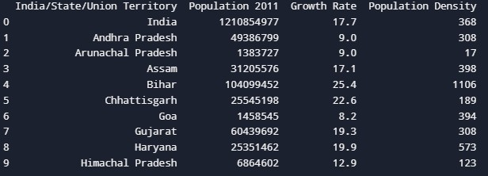

SQL QUERIES
  - Write a query to create a student table with student_id, name, marks, phno, address.

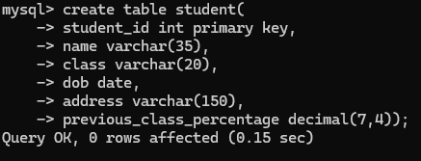

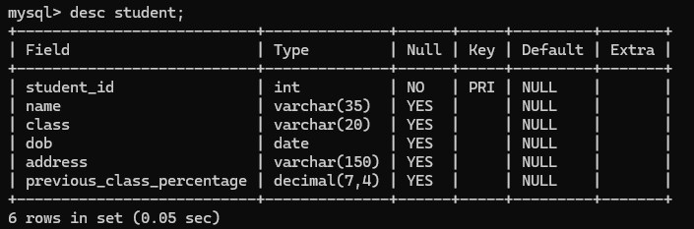

  - Write a query to insert records in student table.

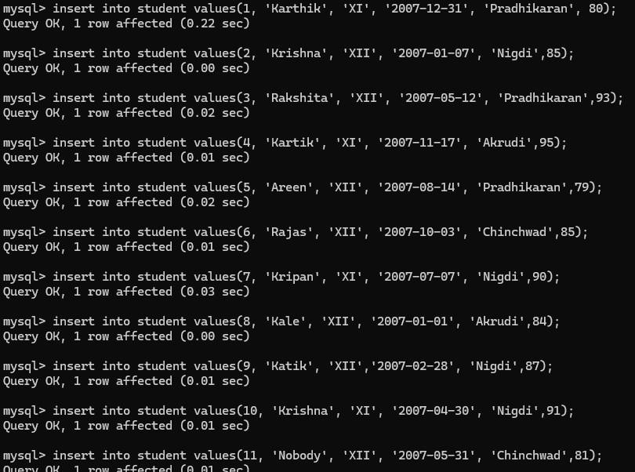

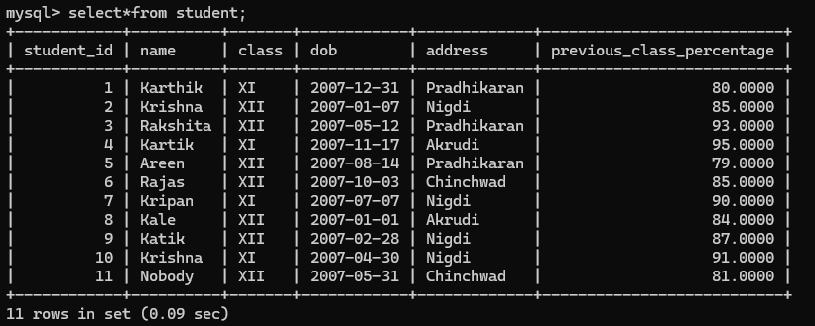

  - Write a query to display details of students with marks > 80.

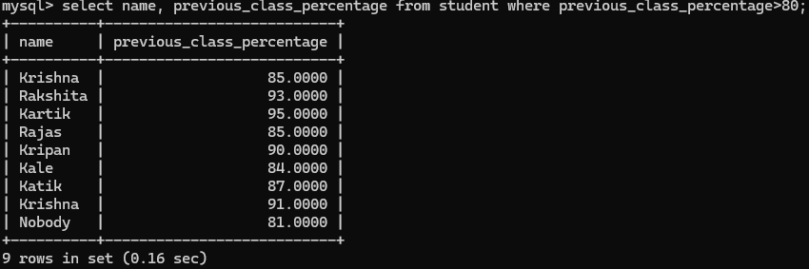
  - Write a query to delete details of a student from above table.

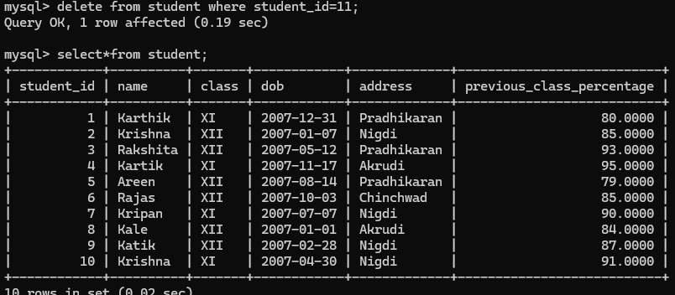

  - Write a query to display all names in lower case.

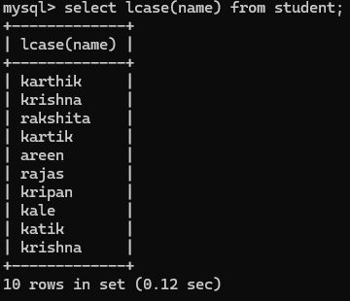

  - Write a query to display complete table after rounding off data to 1 decimal place.
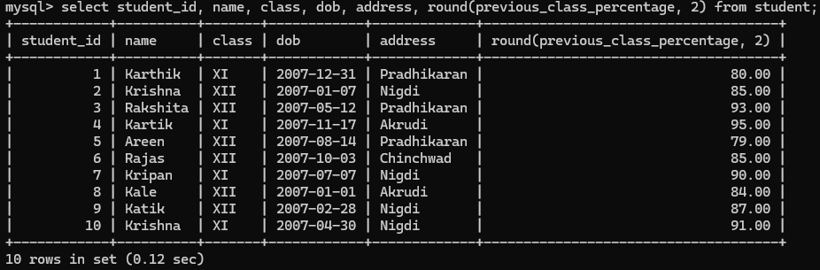

  - Write a query to display occurrence of string ‘a’ in names.

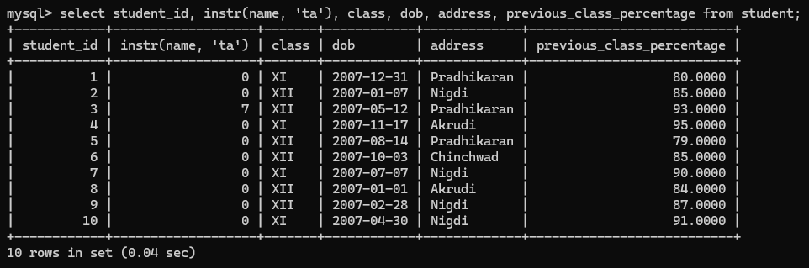

  - Write a query to display weekday of date of birth of all students.

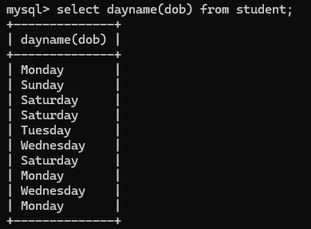

  - Write a query to display count of names of students starting from ‘M’.

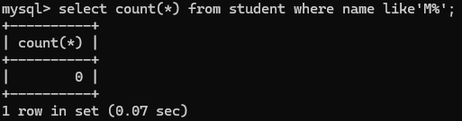

  - Write a query to find min, max, sum and average of marks in student table.
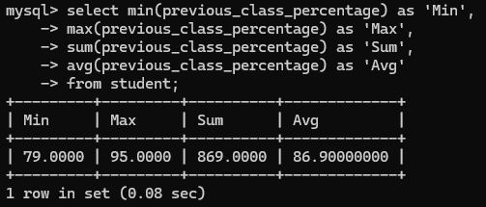

  - Write SQL Query to print student_id and marks in the descending order of marks.

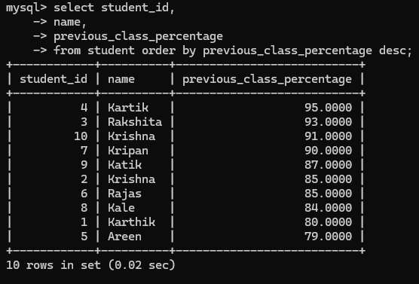
  - Write a query to find total number of students residing in a particular area using group by.

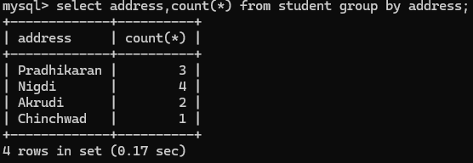

  - Write a query to :
    - Create a table marks that stores marks of students for 3 subjects physics, chemistry, maths,
student names.
    - Join the two tables (student and marks) and print the complete data.

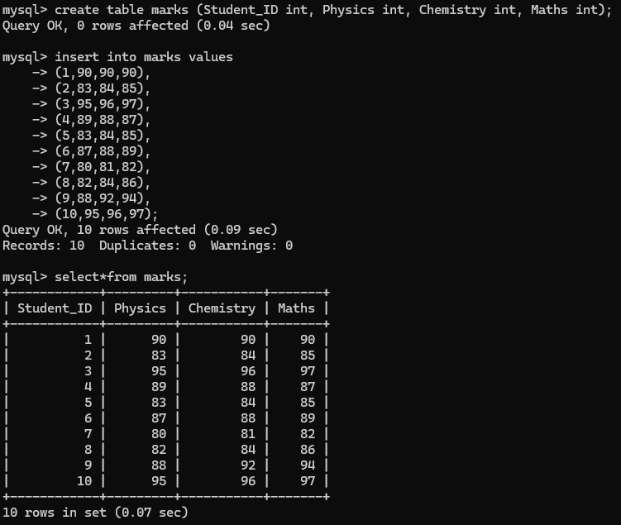
  - Write a query to print name, address and physics, chemistry, maths marks.
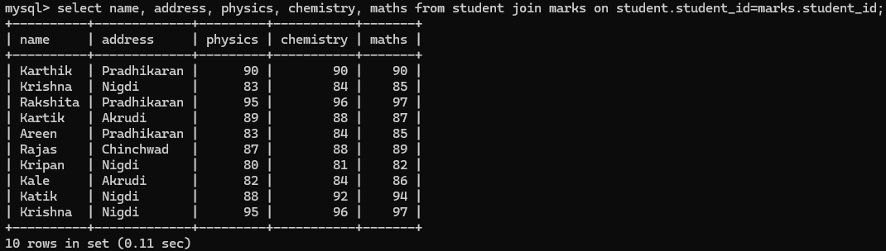

  - Write query to print name and total of physics, chemistry & maths marks.

